

**Ecoshopee: Exploring Consumer Awareness and Perception of Material Composition in Online Shopping**

Presented to the Department of Software Technology

College of Computer Studies

De La Salle University - Manila

Term 3, A.Y. 2023-2024

In partial fulfillment of the course

STHCIUX - Human-Computer Interactions

**MCO2 and MCO 3: Design Portfolio (S13 - Group 5)**

*Submitted by:*

Cabinbin, Pierre Genric N.

Dela Peña, Christian A.

Estañol, Miguel Francis M.

Garcia, Aurelio Rodolfo F.

Javid, Isaac D.

Jovellana, Reuben Seth G.

Sanchez, Chloe Jeanine E.

*Submitted to:*

Mr. Ryan Austin Fernandez

*Submitted On:*

August 8, 2024

**Work Models, Personas:**

Following our needfinding study, the following models are derived from the survey results and interviews conducted by the researchers. These models illustrate the cultural context of the participants, highlighting their expectations, desires, values, and the written and unwritten policies that influence their online shopping behavior. We have identified three distinct models representing different user personas based on their occupation and shopping intentions. Each model is structured around four key categories, which align with our research questions and provide a comprehensive view of the participants' shopping habits and preferences. These categories are:

* **Material Preference** - This category explores the types of products participants are primarily interested in and the importance they place on the quality and composition of these products.
* **Risk and Safety Perception** - This examines how participants assess the authenticity and safety of the products they purchase, including their awareness and consideration of potential risks associated with material composition.
* **Device Preference** - This category identifies the devices participants prefer to use for online shopping, considering factors such as convenience, accessibility, and functionality.
* **Buyer Behavior** - This analyzes the frequency of participants' online shopping activities, the features that most attract their attention to products, and the motivations behind their purchasing decisions.

The cultural models serve as a framework for understanding the participants' mindset. It defines their expectations, desires, and values, and captures the various influences that affect and constrain their shopping behavior.



*Model 1 - University Student*



*Model 2 - Hobbyist*



*Model 3 - Student Intern*

**Brainstorming**

Our brainstorming process is the first step in shaping the direction of our design project. The focus was on developing a mobile-centric e-commerce platform that effectively communicates essential product information, including pricing, ratings, and safety warnings. Any future design must ensure a seamless transition from the current e-commerce formula and a user-friendly experience.

As we began our brainstorming sessions, we concentrated on key areas of focus identified through our study and research. Each area was considered to ensure that our design decisions would resonate with users and meet their needs. One of the primary findings from our study was the high prevalence of mobile phone usage for online shopping. This insight led us to prioritize mobile design. We focused on creating a mobile-first design, where the placement and hierarchy of information were specifically tailored to the mobile experience.

The needfinding also revealed that the first element most users notice when shopping online is the price of the product. This finding informed our brainstorming around the potential placement of design elements around the immediate radius of the price. Additionally, product ratings emerged as an important factor for users when shopping online. Similar to price, we explored the potential of tying design considerations to ratings, where products with lower ratings or unverified sellers might trigger additional warnings or alerts to caution users about potential risks. Given the concern about toxic chemicals in everyday products, we also discussed the possibility of incorporating warnings related to regulated substances.

In our discussions on warning labels, it is important to recognize the importance of conveying information without overwhelming the user. We considered the necessity of including labels that guide the proper usage of potentially toxic products. Although the quantities of toxic chemicals in everyday products are often not lethal, improper use can still pose significant risks. We brainstormed ways to integrate clear and concise warnings, such as using preexisting symbols found within everyday products. These symbols are universal, and generally understood as warnings of precautions that users inside and outside of e-commerce platforms can understand. Additionally, the responsible disposal of toxic chemicals, which is often complex and time-consuming to convey, was another area of focus. However, we acknowledged the risk that users might easily skip this information, leading us to consider alternative methods to emphasize its importance. Shifting our attention to user awareness, we explored the idea of introducing an eco-rating system similar to product ratings. This would provide users with an at-a-glance understanding of a product's environmental impact. Our brainstorming sessions considered how to best integrate this feature without compromising the overall user experience.

Information hierarchy is another area of focus. The goal was to ensure that users received the necessary information at the right time without overwhelming them with too much detail upfront. We brainstormed the addition of search keywords and filters related to hazard warnings which allowed users to easily find products that meet their safety and sustainability criteria. Furthermore, to avoid information overload, we discussed the importance of making warning labels viewable only when users click on a product, or even specifically at the warning labels only, to keep the initial browsing experience clean and straightforward while ensuring that detailed safety information is available when needed.

Our brainstorming process ultimately led to these three key areas for prototyping: the location of warnings, the content of warnings, and the information hierarchy of warnings. We explored various options for where to place warnings within the mobile interface, considering user behavior and preferences. We also identified the most critical information that should be included in warnings, focusing on clarity and user safety. Finally, we discussed the timing and method of presenting warnings, aiming to provide users with the right information at the right time without disrupting the overall shopping experience.

**Affinity Diagram**

To supplement our brainstorming process, the group also made use of an affinity diagram using Google Jamboard. Any suggestions made within the affinity diagram must answer the question “How might we provide online shoppers with clear and accessible information about the material composition of products to enhance their purchasing decisions and promote responsible consumption?”. Suggestions were then grouped into four candidate solutions namely: Enhanced product information, UI improvements, Incentive programs, and Community features.

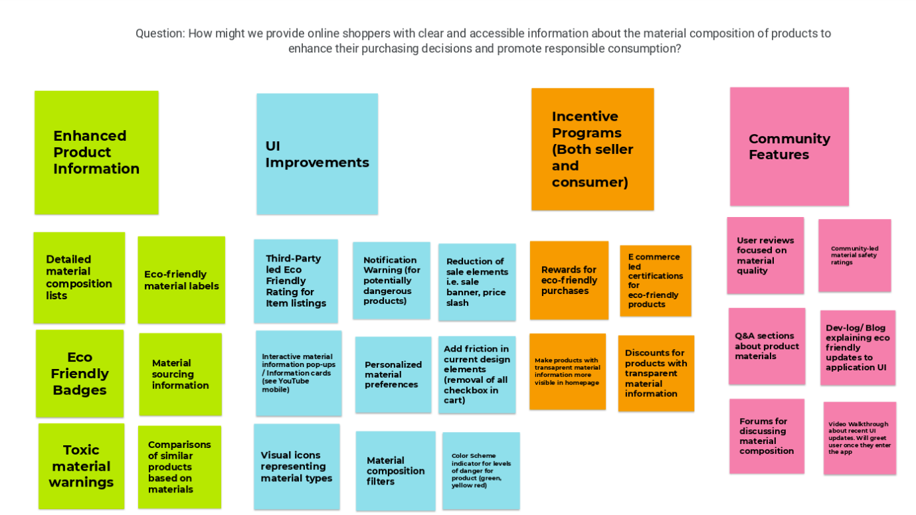

*Affinity Diagram*

This diagram not only mirrored the diverse ideas we had brainstormed but also provided a structured way to group related concepts and identify patterns. As we arranged the ideas into categories, what stood out was the emergence of not only proposals for the inclusion of certain design elements but also suggestions for the exclusion of others. This was particularly significant as it highlighted a shift in our approach, where the focus expanded from merely adding new features to rethinking portions of the existing e-commerce formula.

One of the realizations from this process was the need to reconsider the typical "in-your-face" advertising commonly seen on e-commerce platforms, especially regarding markdowns and sales. These aggressive marketing tactics can more often than not lead to impulsive buying behavior which is in a pure contradiction of what we want to achieve which is a more mindful and deliberate shopping experience.

In addition to focusing on potential hazards and the empirical aspects of e-commerce design, the subsequent affinity diagramming introduced a new dimension centered on human-centric design. This approach, as opposed to the traditional business-centric focus, emphasized the inclusion of categories like incentive programs and community features. These ideas aimed to enhance the user experience by fostering a sense of belonging and rewarding responsible behavior which, in turn, creates a more engaging and socially responsible platform.

After some deliberations, the team decided to narrow down the focus to the first two candidate solutions. The rationale behind this decision was based on the observation that the ideas within these categories addressed significant and prominent aspects of what users typically encounter on e-commerce platforms. By prioritizing these areas, we ensured that our design would have a substantial impact on the overall user experience. While the latter two categories introduced valuable concepts, they were considered more as "nice-to-haves" rather than essential components, leading the team to concentrate on the more impactful elements. In addition, the group also felt potential difficulties in the design and implementation of the latter two within the low and high-fidelity prototypes

**Low-Mid Fidelity Prototypes**

Building on the insights gained from our affinity diagram, the next phase of our design process involved the creation of low-fidelity prototypes. Members available during this phase have been tasked with creating hand-drawn prototypes that reflect the previous discussions. The group came up with the following low to mid-fidelity prototypes:

|  |  |
| --- | --- |

Low Fidelity Prototypes by Isaac Javid feature warning labels beside the price and as an element below the product title. Product warnings should at most have 2 of the most dangerous hazards found within a specific product.

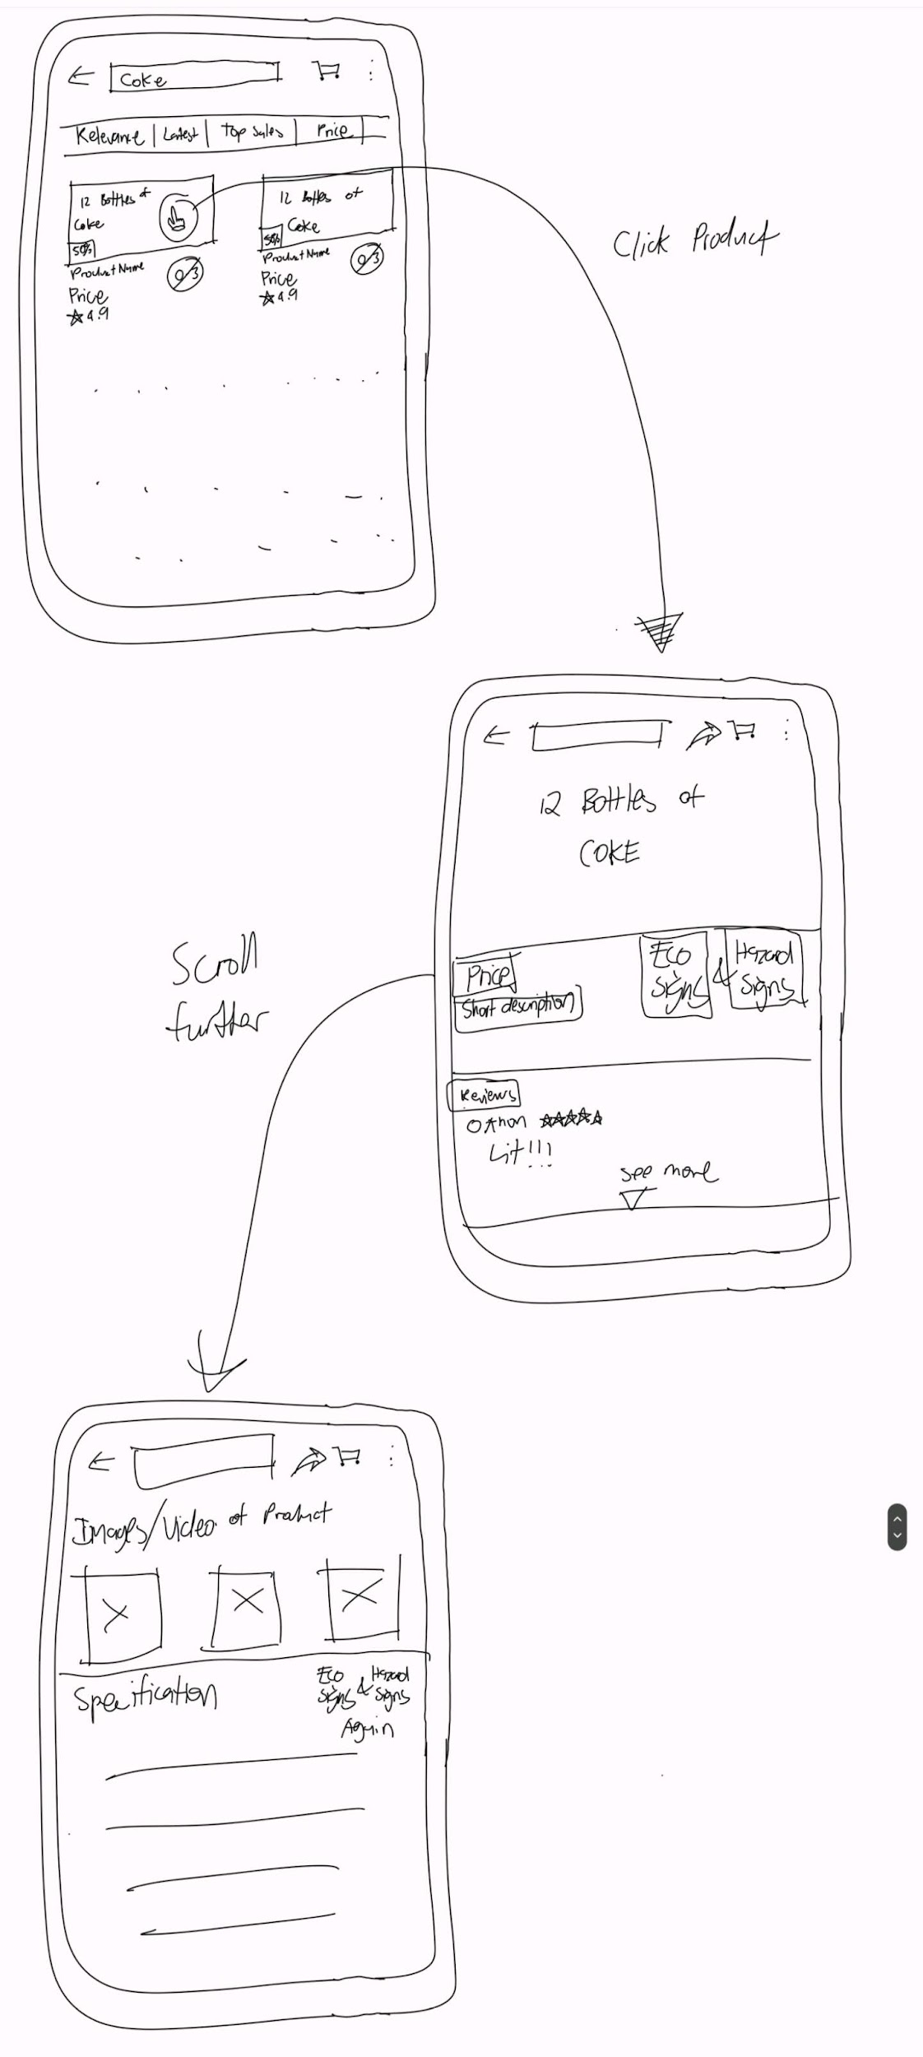

|  |
| --- |

Low Fidelity Prototypes by Christian Dela Peña feature warning labels within the landing page, specifically on individual item listings. Designs also feature icons beside the price for detailed item listings. Dela Peña’s design also features a drawer-type UI piece, as opposed to Javid’s description being shown immediately below the primary descriptions and elements of the detailed listing.

|  |
| --- |

Low Fidelity Prototypes by Pierre Cabinbin. The left side features color-coded product listings based on hazard level. Cabinbin’s design considerations are different from the other two when it comes to the placement of warnings as he places them beside the ratings. This also features a description portion, but instead of a drawer UI, Cabinbin opted for a tabbed design wherein the user can switch between one set of information to another

The right side featured another design iteration from Cabinbin’s work. For this version, he places the warning label on top of the image of the detailed listing. This design consideration also applies to the individual listing that a user may find on the landing page

|  |
| --- |

Another design by Cabinbin focuses on the warning labels as a collapsible tab that the user can open and close.

|  |
| --- |

Mid Fidelity Prototypes by Miguel Estañol. This design follows closely with the typical layout of the current mobile UI used by e-commerce platforms. The design features eco-friendly badges placed beside the listing price, a different approach from the warnings labels by Dela Peña and Javid. Warning labels are instead placed underneath the description. Clicking on the chevron found within this section will allow users to view the warnings and their corresponding, in addition to the disposal guide for said products. This design also features a community-driven expanded rating system to accommodate for the environmental factor of a material. This idea was ultimately dropped after this iteration.

**New Ideas**

This section presents some new ideas brought to the table as the group began iterating over the low and mid-fidelity designs.

|  |  |
| --- | --- |

Ideas by Seth Jovellana features an alternative warning card (left), and drop-down notification (right) that will notify the users of any potentially harmful materials within a product.

The first design notifies users through a warning notice that explicitly lists the toxic chemical compounds present in the product. This notice would include a "Learn more" link that redirects users to a credible website offering detailed information about the potential dangers associated with the listed chemical compounds. This method is practical as it directly informs users about risky ingredients, allowing them to make informed decisions. However, a downside is that the warning notice could easily be overlooked by users as they scroll through the product listing, potentially missing this crucial information.

Alternatively, the warning could be presented as a notification that appears whenever a user clicks on a product containing toxic chemical compounds. This approach ensures that the warning is seen, as it effectively grabs the user's attention, making it less likely to be missed. The notification would also include a "Learn more" link for further information on the chemical compounds. While this method is highly effective in alerting users, it can make the user experience feel intrusive. Additionally, there is a risk that the notification could be lost among other notifications on the user's phone, or it could become overwhelming if the product contains multiple toxic ingredients. This challenge could be mitigated by categorizing the level of risk with case-specific messages such as "This product has a few risks," "This product has several risks," or "This product is relatively safe."

|  |
| --- |

Ideas by Aurelio Garcia featuring a “list of risks” strategically placed near the product's price or rating. When the button is clicked, an interstitial screen appears that will present a list of potential risks associated with the product. This list is categorized into sections such as allergens, general health risks, environmental risks, and waste products. Each category is represented by an icon, and tapping on any icon reveals the specific risky ingredients related to that category.

This approach is comprehensive as it offers users more detailed information. However, it does require user interaction, which could be overlooked by those focused on finding a specific product. Additionally, organizing the information effectively—considering factors such as the degree of risk and proper classification—could present a challenge. There is also the potential to overwhelm users with an abundance of information, which might detract from their overall shopping experience.

**Checkpoint 1: Conclusions, Realizations, Future Directions**

In the initial phase of our design process, we identified several key trends and patterns that shaped our approach:

* Trend 1: Our proposed design informs users of product hazards directly through the catalog view. This makes hazard warnings immediately visible as they browse. Further details about these hazards could be accessed by clicking on the product, where the information would be displayed in a dedicated tab, similar to the "Specifications" tab commonly found on product pages. This tab would also include disposal information and would be strategically placed near the product's price and ratings to ensure visibility and relevance.
* Trend 2: Another approach considered was displaying product hazards similarly to notifications, positioned at the top of the screen whenever a user clicks on a product containing toxic chemical compounds. This notification would provide an option to "Learn more," redirecting users to a credible website with detailed information on the potential dangers of the chemical compounds. This method is designed to ensure that the hazard information is seen immediately upon interaction with the product. However, suggestions made during group discussions stipulate that notifications must be made available within the app only, and not through the actual mobile operating system. This approach circumnavigates the issue wherein notifications are buried under other mobile notifications
* Trend 3: A third trend involved placing a button near the product's price or ratings, which, when pressed, would reveal detailed information about the product's hazards. This button would allow users to toggle and select specific hazards they are interested in learning.

Reflecting on our current design based on the identified trends, it becomes evident that some significant weaknesses need to be addressed. One major concern is the placement of hazard warnings in our designs. While the intent was to ensure that users are well-informed about potential risks, the warnings have become more prominent and "in your face" than initially anticipated. This level of visibility might actually dissuade users from completing their purchases on e-commerce platforms. If users are constantly bombarded with warnings, it could create an atmosphere of fear or distrust, leading them to abandon their shopping carts.

Another weakness in the design is the volume of information presented to users at any given time which may result in users getting overwhelmed by the amount of data they need to process. This information overload can lead to decision paralysis, where users struggle to make informed choices because they are bombarded with too many details at once.

Circling back to the warning elements, there is the risk that by integrating too many warning elements into the interface, we might inadvertently cause users to become desensitized to the warnings. If every product is flagged with some form of hazard or risk, users might begin to ignore these alerts, assuming that they are not significant or relevant to their purchasing decisions. This could undermine the entire purpose of our design, which is to ensure that users make informed, responsible choices when shopping online.

As we move into the mid-to-high fidelity prototypes, it's crucial to keep several key considerations in mind to refine and enhance our design. First, we need to find a balance between effectively communicating hazards and maintaining a user-friendly experience. This means reconsidering the placement and visibility of warnings to avoid overwhelming or deterring users while still ensuring that important information is readily accessible. We should also focus on optimizing the information hierarchy to streamline the user journey. Additionally, simplifying user interactions will be essential—our designs should minimize the steps required to access critical information. Finally, it is important to avoid desensitizing users with too many alert cues. Thus, we should prioritize clarity and relevance.

Building on our initial ideas, there are several key areas we can expand upon to improve our design further. We need to explore ways to expand the content within notifications or consider alternative methods to convey more comprehensive information without overwhelming the user. The current approach of pressing a hazard button near the price or rating to access information requires users to engage in heavy interaction, which may not be ideal. Enhancing the information hierarchy will be crucial in this context. Integrating warnings into the app’s interface also presents an opportunity for improvement. We must refine how these warnings are presented to avoid scaring users or causing them to overlook critical information.

**Mid Fidelity Prototypes:**

The transition to mid-to-high fidelity prototypes in our design process was marked by several challenges, particularly the lack of sufficient time to consolidate a single design for further development. As a result, each team member took the initiative to iterate on their designs independently.

The group came up with the following mid fidelity prototypes:

|  |
| --- |

High-fidelity prototype by Pierre Cabinbin based on his initial low-fidelity prototype.

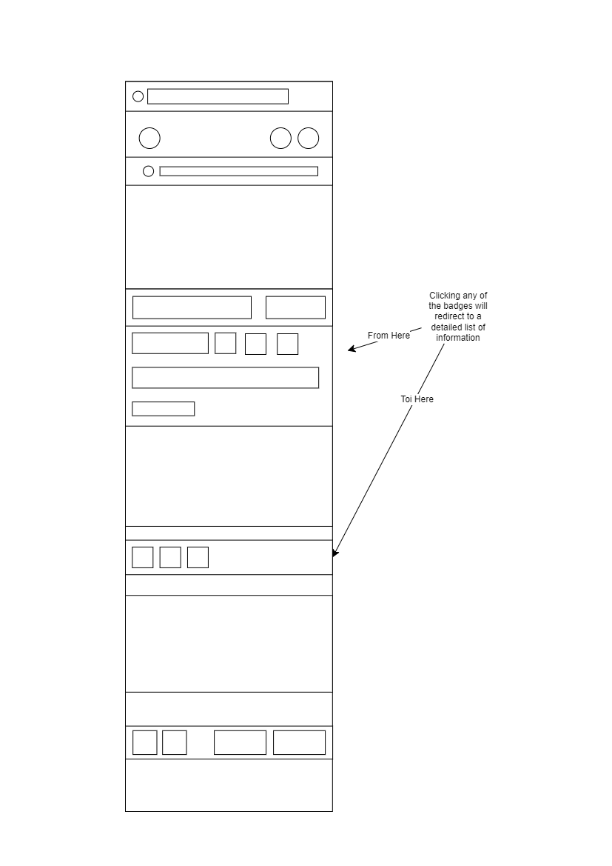

Mid-fidelity prototype by Miguel Estañol on the functionality of the proposed badges beside the price

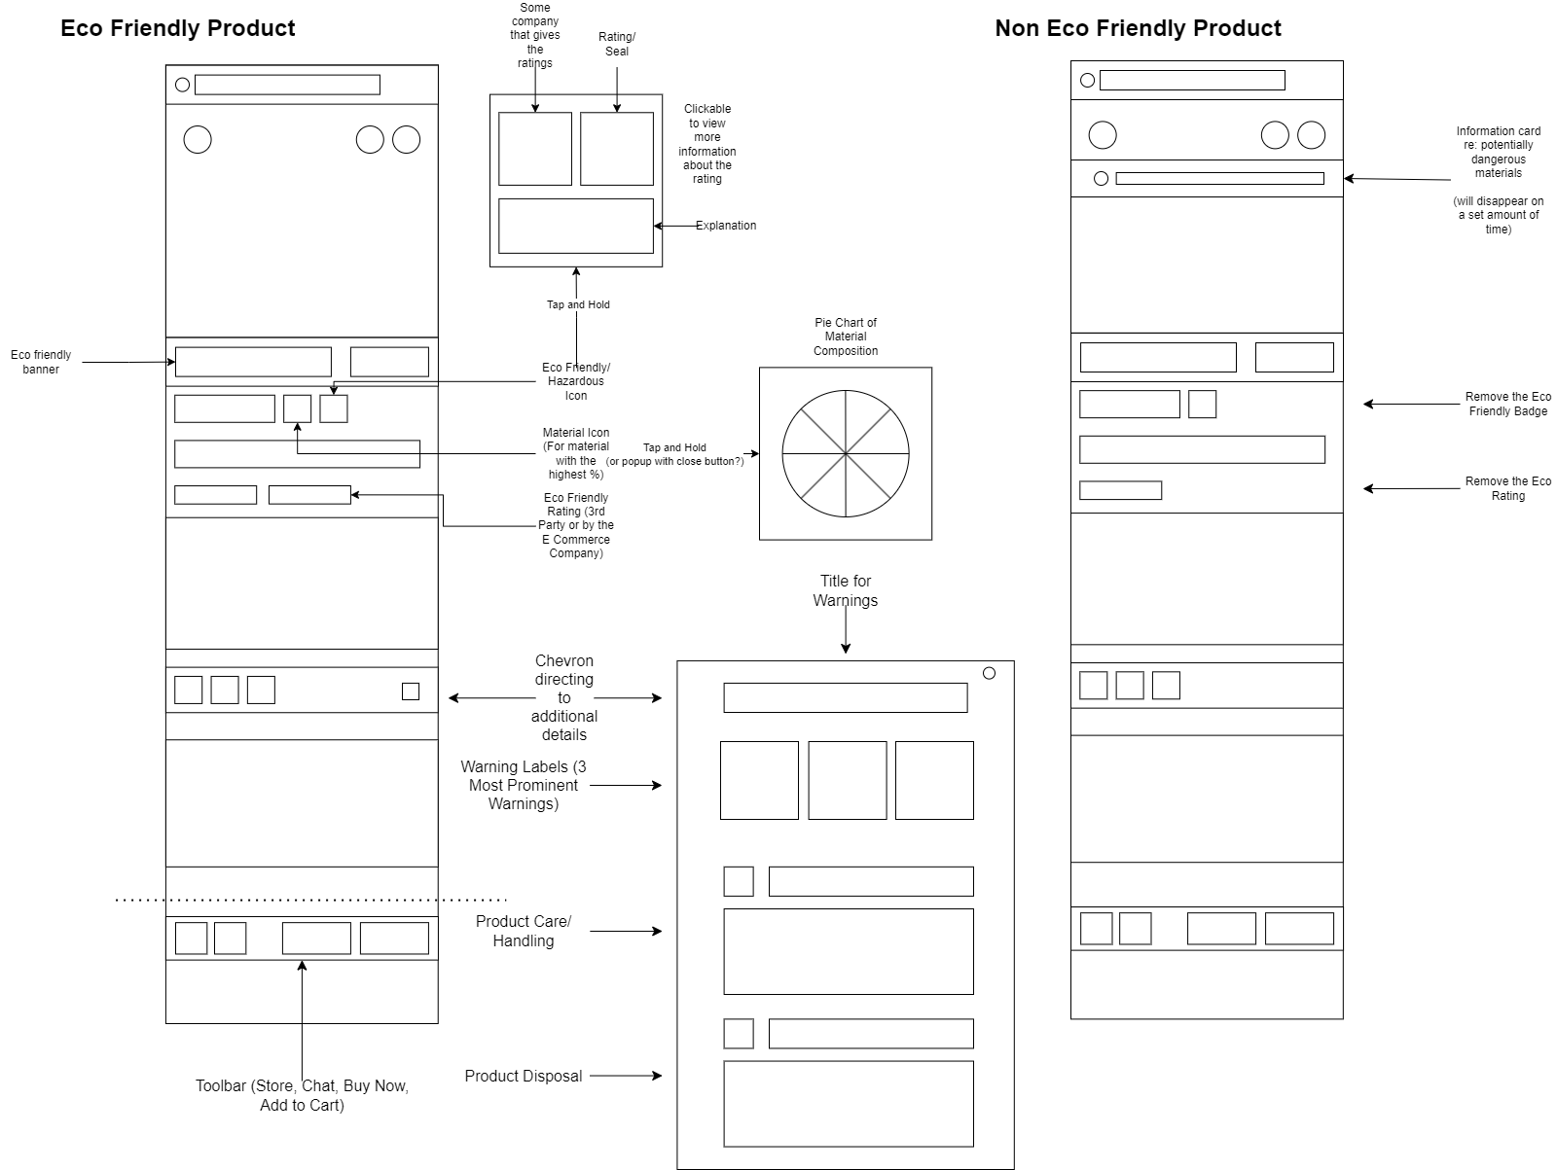

Mid-fidelity prototype by Miguel Estañol based on Checkpoint 1. Estañol made several additions. For eco-friendly products, an eco-friendly banner has been added in place of a typical sale banner. Integration of material composition information through a pie chart of the most prominent materials found within a product has also been added. Product warnings have also been updated to accommodate product care/ handling (depending on the product) and disposal guides. Non-eco-friendly products share the same elements, excluding the eco-friendly badge. In addition, it also includes an in-app notification that will notify users of the presence of dangerous materials

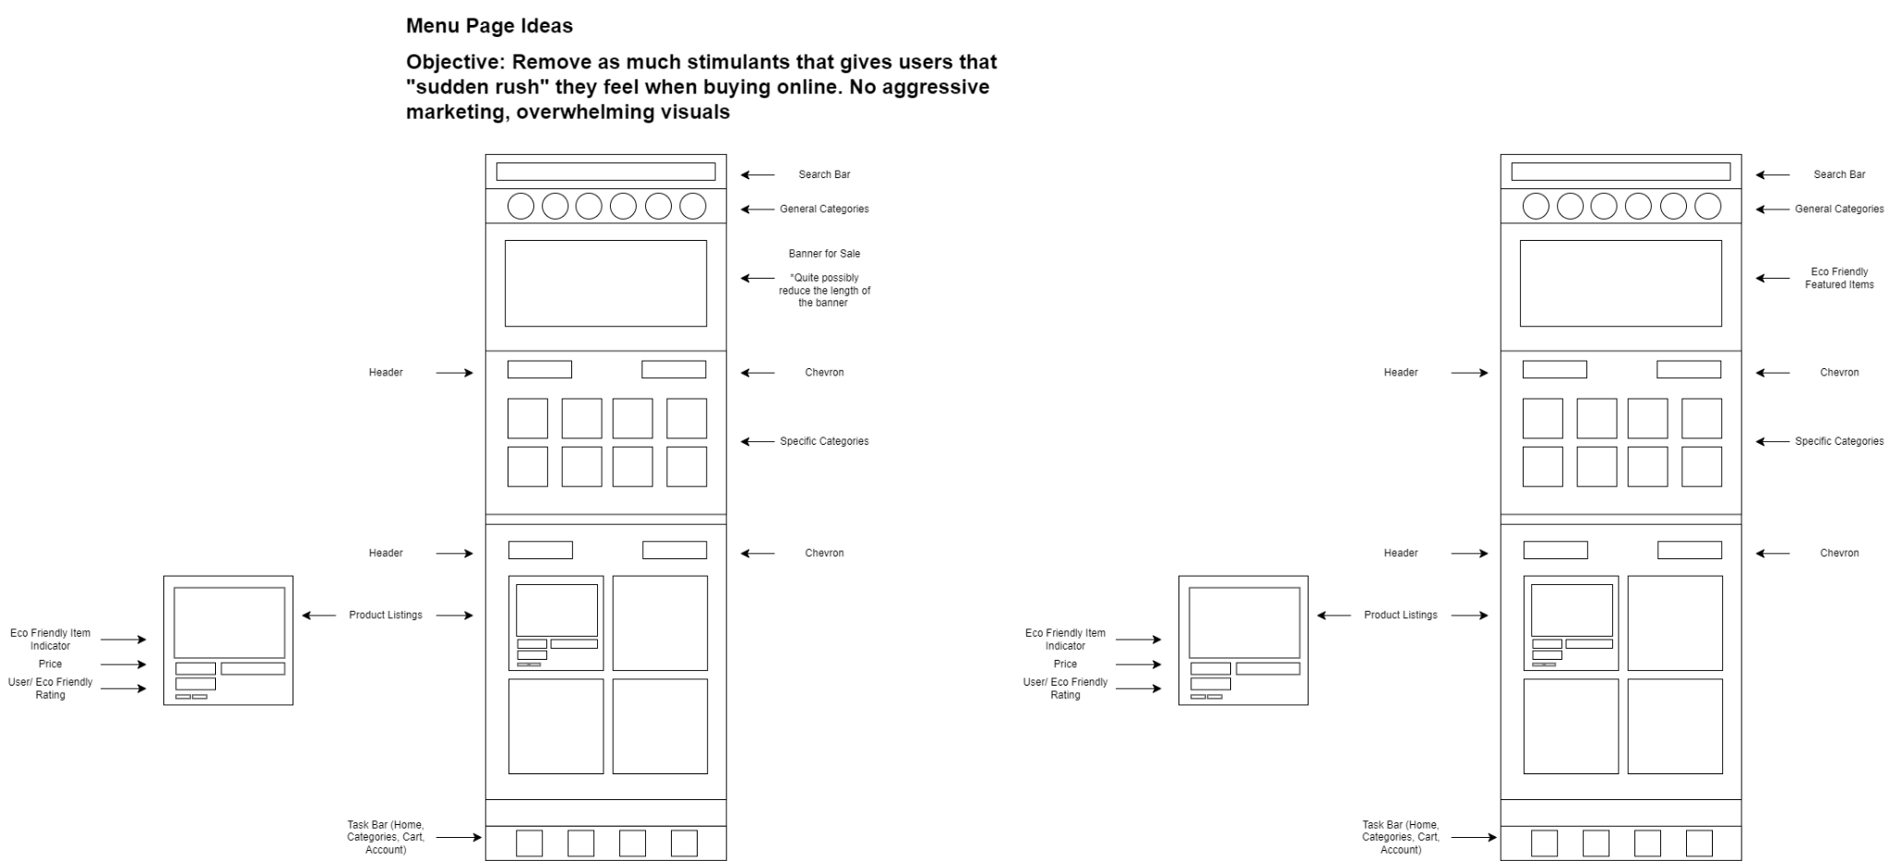

Mid-fidelity prototype by Miguel Estañol for the menu or landing page. This page more or less mirrors the current e-commerce layout. However, the designer made it the primary objective to exclude as much of the bloat that comes with the traditional e-commerce platforms with regards to sales as they provide the stimulants for users to impulsively shop online.

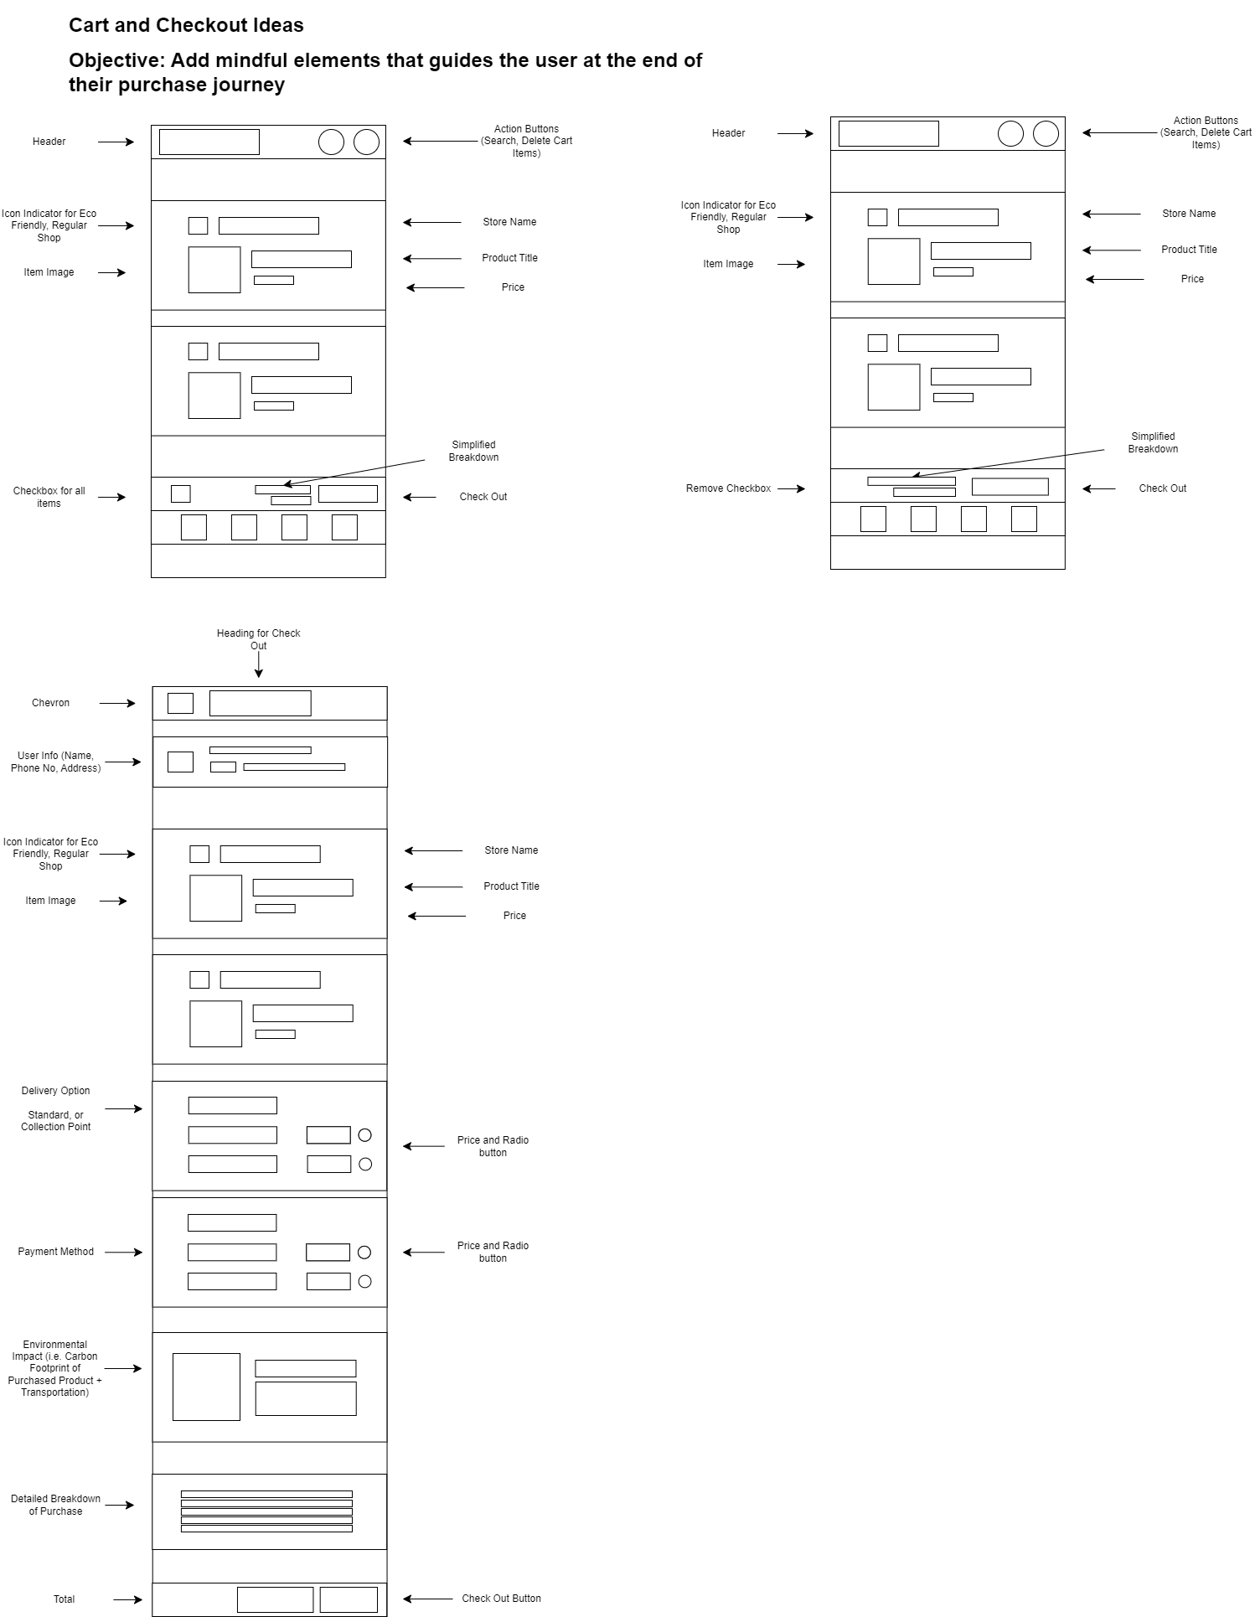

Mid-fidelity prototypes by Miguel Estañol on the cart and checkout page. The cart section mainly introduces two changes. First, eco-friendly stores get a unique icon used as an indicator for their platform. Another is the removal of all checkboxes before users can proceed to checkout. This adds additional friction for users to manually select items for checkout in the hopes that a more mindful attitude is taken before they reach the end of their shopping experience.

The checkout also saw the addition of an additional delivery option which lets users pick up their items at a designated pick-up point and the addition of the estimated carbon footprint that their purchase generates.

**High Fidelity Prototypes:**

The high-fidelity prototype section of our report represents the culmination of our iterative design process. This stage involved developing interactive prototypes that closely mimic the final product, allowing us to evaluate the design’s effectiveness in a real-world context. In this phase, we also conducted evaluations through usability reports to refine our concepts. A total of three respondents were invited to test four candidate user interface designs. Following these evaluations, the group members were required to unanimously vote for the final design, which would be featured in our presentation on August 08, 2024. The group came up with the following mid fidelity prototypes:

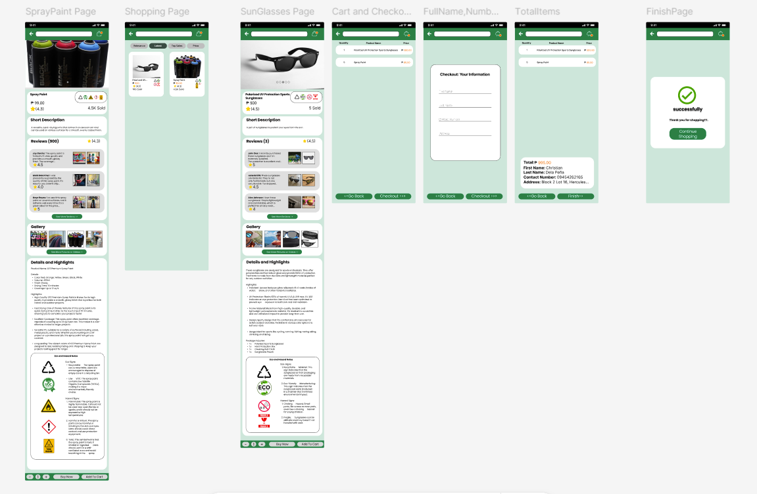

High-Fidelity Prototype by Christian Dela Peña. This hi-fi prototype draws inspiration from other e-commerce applications like lazada or shopee but with few modifications such as adding eco & hazard signs as well as their explanations in their respective products. This was done in mind to provide awareness to potential buyers of a product. The simplicity of this design is based on the fact that providing some form of awareness should be enough and that the users should not be overwhelmed with lots of information because if it were to overwhelm them then the user would not care or be aware.

Feedback from respondents: While the UI was praised for its visual appeal and intuitive checkout process, several usability issues were identified. The hazard information button was difficult to identify, as it did not look interactive, and the homepage allowed users to continue scrolling upward even when no additional items were available, creating potential confusion. The checkout flow was noted to lack interactive elements for inputting user information, which could enhance the realism of the process. Additionally, the lack of feedback when adding items to the cart was pointed out, with suggestions to implement a pop-up notification or a visible message indicating the quantity of items added. Lastly, the homepage icon could be improved by using a "House" symbol to clearly signify when the user is on the homepage. These insights provide valuable direction for refining the prototype.

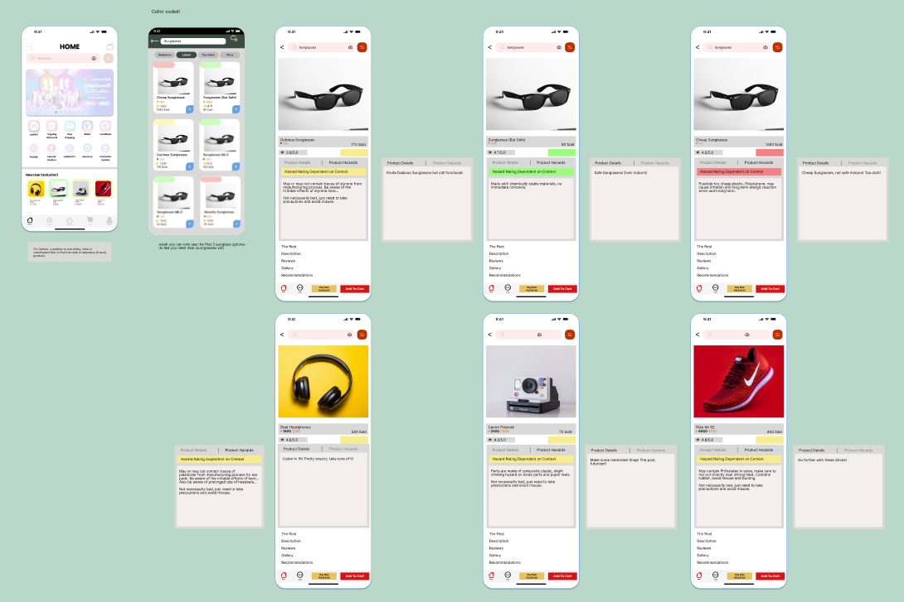

High-Fidelity Prototype by Pierre Cabinbin. This design incorporates his proposed plans for a non-intrusive, color-coding system for item listings and their corresponding detailed format. This design also integrates the tabbed presentation for product detail and hazards, a design consideration made at the first checkpoint. This approach was made with a focus on the location of the hazard warnings, placing the hazard details up top instead of below; Contrary to the layouts in common shopping apps like Lazada where they have the gallery, recommendations, and vouchers first before you’re able to see the product’s details.

Feedback from respondents: Disproportionate with regards to the provided information. Product Hazards has more information vs. product details. Overlapping elements have been observed, which led to some errors. Respondents succeeded in testing for the most part.

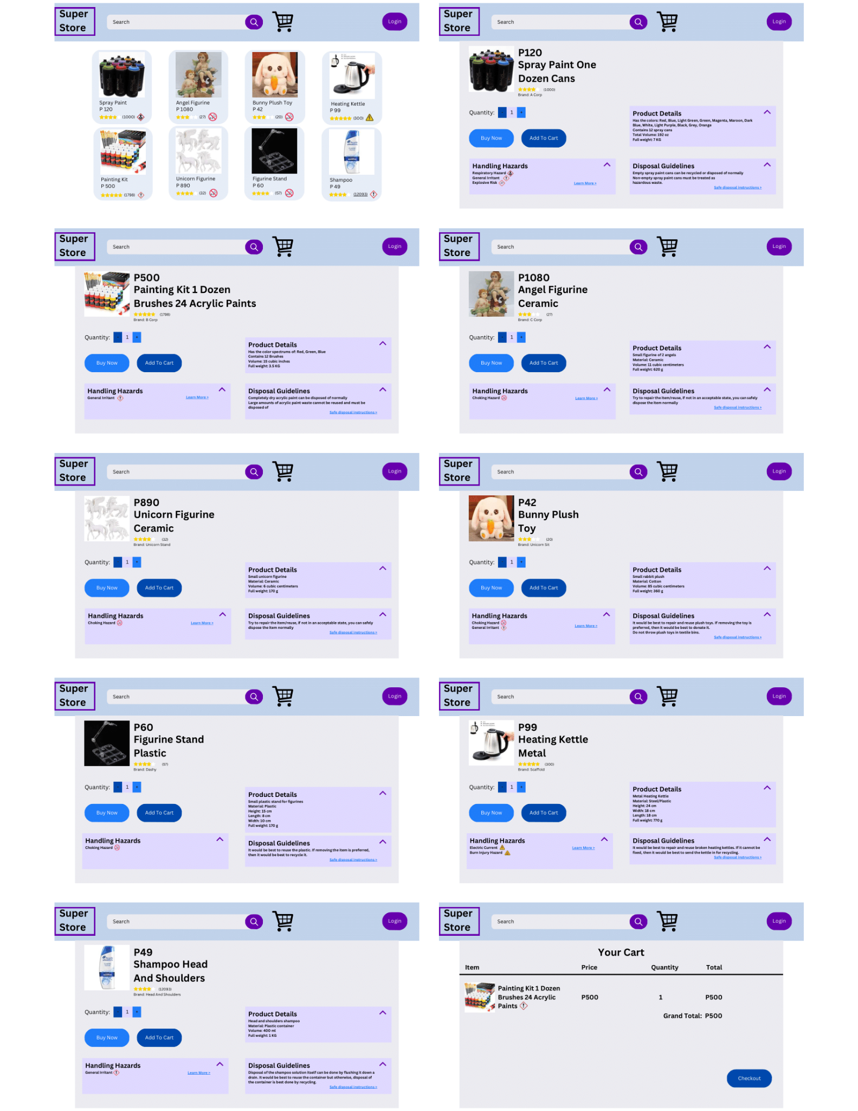

High-Fidelity Prototype by Isaac Javid. The Products on the home page contains hazard signages to give the users a small idea of the hazards. By clicking a product, the user is then made known of other features not typically seen on a standard page of a product. In the Product Details section, the major characteristics of the product are then shown. The Handling Hazards section contains the hazard signs relating to the product and there’s also the Learn More section which is an external link that sends them to a website explaining more information about the product’s hazards. There’s also a Disposal Guidelines section which gives a gist of disposing the product properly and there it contains Safe disposal Instructions is an external link that sends them to a website should they want more info.

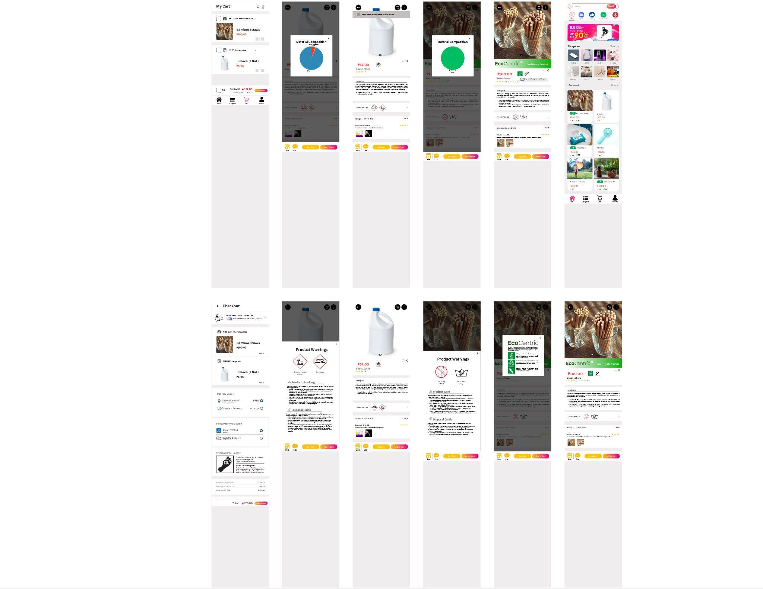

The first iteration of the High-Fidelity prototype by Miguel Estañol. This incorporates all of the ideas from the mid-fidelity prototypes by the designer. The design is heavily based on existing e-commerce websites like Shopee and Lazada.

Feedback from respondents: The notification color combination of gray and black makes the notification difficult to read. In addition, the designer was asked if other design considerations have been considered for the eco-friendly and material composition badges within the detailed listings page. There had been considerations for pursuing a tap-and-hold functionality for the aforementioned badges. However, due to the limitations of the chosen Wizard of Oz platform, the functionality cannot be achieved. Respondents praised the proposed design for its intuitive design considerations and seamless transition.

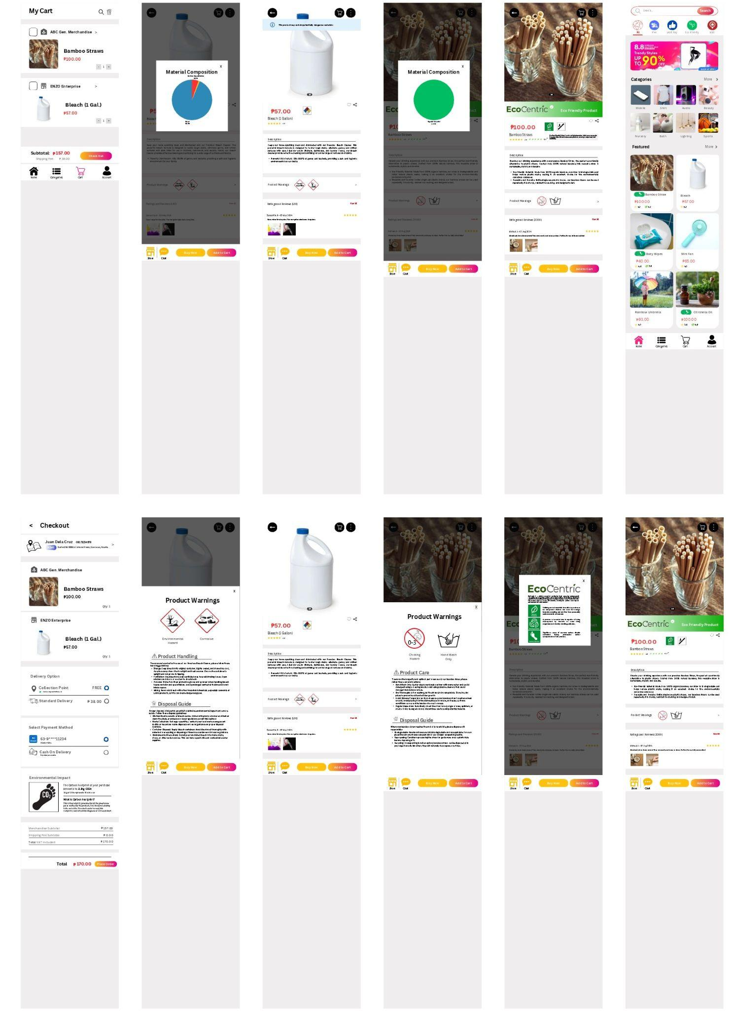

The second iteration of the High-Fidelity prototype by Miguel Estañol. This builds on the feedback provided by our respondents on the first iteration. Due to the same limitations mentioned during the first iteration, the designer has decided to retain the functionality for opening details within the badges. Notifications warning users of potentially dangerous materials have been updated to a transparent blue color, similar to information cards on platforms such as YouTube.

Feedback from respondents: The feedback from the second iteration of the UI design highlighted some usability challenges that need to be addressed. Users reported difficulty navigating the Bamboo Straws listing, particularly when clicking on the image instead of the product name, suggesting a lack of interaction cues. Additionally, the warning images were mistaken for interactable elements. A significant observation was the challenge in locating the material compositions, as users were unfamiliar with its presentation in the interface. A suggestion was made to use a uniform symbol, such as a combination of a paper bag or box with a pie chart, to depict "Material,".

**Final Prototype**

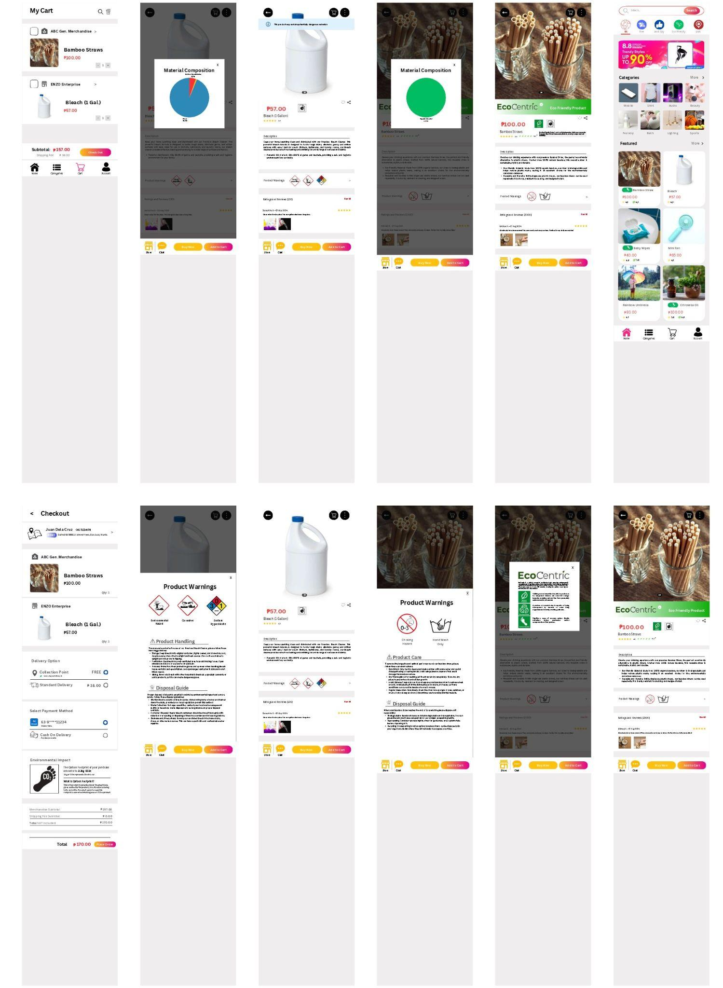

The final prototype is the design by Miguel Estañol, chosen due to its close integration with the Lazada platform which showcases the nature of the solution as a plug-in, along with the integration of indicators of eco-friendly indicators to encourage shoppers to act and be made more aware of eco-friendly alternatives in both the actual products, their sellers, and the delivery methods. Doing this would add positive aspects to the plugin aside from the hazards, warnings, and handling guidelines that were commonly planned for the plugin. Additionally, more complex information such as the specific product breakdown would allow users to make more in-depth connections between materials and their effects and handling and disposal information.

According to the testing information and observations made by the team, the prototype addresses the design problem properly in which it allows the user access to information regarding hazardous materials, responsible product handling, and responsible product disposal. Additional information in the form of the eco-friendliness rating of the product and eco-friendly alternatives also allow users more information to contribute to the purposes of the SDG and sustainable development. However, the prototype will still need improvements towards better accessibility and effectiveness. Some issues observed during testing and general operation included users potentially missing the information due to its lack of prominent display due to information overload concerns and lack of space, or the accessibility issues of certain icons being too small. Further improvements after further tests may also be made towards changing the contents of the handling and disposal information to accommodate better placement and digestibility for users to see and further absorb.

**Final Words**

The team chose to address the UN Social Development Goal of Sustainable Consumption and Production. Specifically, our goal was to inform online shoppers of the hidden risks in the everyday products they buy. Some extremely powerful businesses spend a lot of money trying to keep this information out of public knowledge, causing countless people to suffer severe reactions and increasing the waste unleashed into the environment due to this lack of knowledge.

So, the team decided to research, develop, and implement a UI that would educate consumers on the dangers of these everyday items they buy all the time, both on the risks to themselves and to the environment. In that regard, we believe that we have succeeded. The final UI allows users to learn more about the personal and environmental risks found in the products they shop for online, compiling the information into an accessible and understandable manner: displaying the material composition in a pie chart, and offering various facts regarding the safety and sustainability of the product.

That being said, there are still some improvements that the team can make. There are still some minor issues with how specifically the content can be further organized into one with better respect for the hierarchy of the information and the user’s own attention span (most especially in a world where almost everything is competing for a user’s attention), as well as the sizing of certain icons and the spacing between them. However, these are easily adjustable and addressable concerns that can be quickly resolved with a little more tinkering.

Overall, the project has been a success. The UI can effectively inform users of the environmental dangers and health risks in a clear and concise manner, give them tips on proper disposal and risk management, give them the information they need to make informed decisions regarding their shopping, and allow them to inform others of the risks. While there are still minor adjustments that can be made, the team believes that the prototype is well-designed and will help a lot of people.

**Appendix**